ARTIFICIAL INTELLIGENCE LAB

Lab 4: Informed Search — Heuristics & A*
Week 4 | Lab Task 1 | CLO2 (C3: Apply)

Name: M.Ayyan Khan
Roll No: 042
Section: BSAI-3A

Task 1: Manual A* Trace
Compute g(n), h(n), and f(n) for the first three expansions using the supplied campus graph. For each expansion, show the selected node, the frontier remaining after its successors are examined, and why the next node is selected.

1. Given graph and heuristic values
Start node: S | Goal node: G | Evaluation function: f(n) = g(n) + h(n)
Node | Successors (edge cost) | Heuristic h(n)
S | A (1), B (4) | 5
A | C (2) | 4
B | G (5) | 4
C | G (3) | 2
G | None | 0
Rule used: A* removes the frontier entry with the smallest f-value. If f-values tie, the entry inserted first is selected. Successors are considered in the supplied order.

2. Expansion 1 — select S
Initially, the priority queue contains only S.
g(S) = 0 (no cost has been travelled yet)
h(S) = 5 (the supplied estimate from S to G)
f(S) = g(S) + h(S) = 0 + 5 = 5
Selected node: S, because it is the only frontier entry.
Expand S and add its successors:
• A: g(A) = 0 + 1 = 1; h(A) = 4; f(A) = 1 + 4 = 5
• B: g(B) = 0 + 4 = 4; h(B) = 4; f(B) = 4 + 4 = 8
Frontier node | g(n) | h(n) | f(n) = g + h
A | 1 | 4 | 5
B | 4 | 4 | 8
Frontier after expanding S: A (g=1, h=4, f=5), B (g=4, h=4, f=8).
Next selection: A, because f(A)=5 is smaller than f(B)=8.

3. Expansion 2 — select A
Selected node: A, with g(A)=1, h(A)=4, and f(A)=1+4=5.
A has one successor, C, reached with edge cost 2:
g(C) = g(A) + cost(A,C) = 1 + 2 = 3
h(C) = 2
f(C) = g(C) + h(C) = 3 + 2 = 5
Frontier node | g(n) | h(n) | f(n) = g + h
C | 3 | 2 | 5
B | 4 | 4 | 8
Frontier after expanding A: C (g=3, h=2, f=5), B (g=4, h=4, f=8).
Next selection: C, because f(C)=5 is smaller than f(B)=8.

4. Expansion 3 — select C
Selected node: C, with g(C)=3, h(C)=2, and f(C)=3+2=5.
C has one successor, G, reached with edge cost 3:
g(G) = g(C) + cost(C,G) = 3 + 3 = 6
h(G) = 0 (the goal node has no remaining travel cost)
f(G) = g(G) + h(G) = 6 + 0 = 6
Frontier node | g(n) | h(n) | f(n) = g + h
G | 6 | 0 | 6
B | 4 | 4 | 8
Frontier after expanding C: G (g=6, h=0, f=6), B (g=4, h=4, f=8).
Next selection: G, because f(G)=6 is smaller than f(B)=8. When G is removed from the queue and processed, A* returns the route S → A → C → G with total cost 6.

5. Summary of the first three expansions
Expansion | Selected node | g(n) | h(n) | f(n)
1 | S | 0 | 5 | 5
2 | A | 1 | 4 | 5
3 | C | 3 | 2 | 5
Final path: S → A → C → G
Total path cost: 1 + 2 + 3 = 6

Conclusion
A* selected S, A, and C for the first three expansions because each selected node had the smallest f-value in the frontier at that step. After expanding C, the goal G had f=6 while B had f=8, so G was selected next. The resulting path S → A → C → G has cost 6, which is lower than the alternative route S → B → G with cost 4 + 5 = 9.
Code requirement: This specific Lab Task 1 asks for a manual calculation and frontier trace, so code is not required to answer the task. The lab manual provides a guided Python A* implementation for the separate implementation/comparison activity.

Lab 4: A* and UCS Experiments
Week 4 | Lab Tasks 2 and 3 | CLO2 (C3: Apply)

Task 2: Compare A* with UCS on the Same Graph
Aim: Run A* with the supplied heuristic and Uniform-Cost Search (UCS) with h(n)=0. Keep the weighted graph, start node, goal node, successor order, and priority-queue implementation the same.

1. Graph and heuristic
Node | Successors (edge cost) | Supplied h(n)
S | A (1), B (4) | 5
A | C (2) | 4
B | G (5) | 4
C | G (3) | 2
G | None | 0
Start = S; Goal = G. A* priority: f(n)=g(n)+h(n). UCS priority: f(n)=g(n), because h(n)=0 for every node.

2. Python code Output:
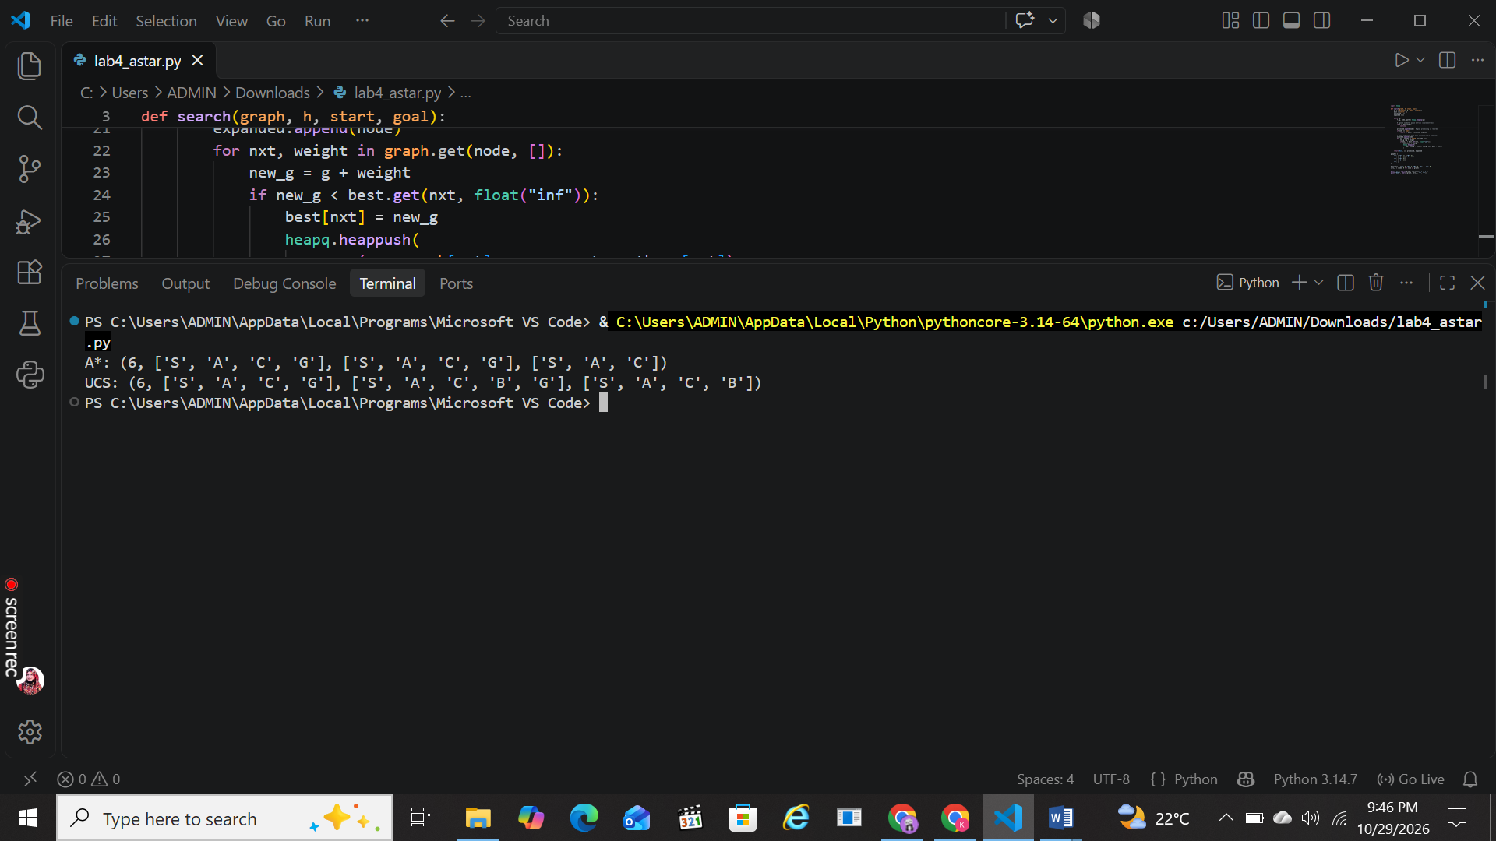

Counting convention: “Processed” means a non-stale node removed from the priority queue, including the goal. “Expanded” means a node whose successors are examined; the goal is not counted as expanded. Stale queue entries, if any, are ignored.

3. Results
Measure | A* (supplied h) | UCS (h=0)
Returned path | S → A → C → G | S → A → C → G
Independent path-cost sum | 1 + 2 + 3 = 6 | 1 + 2 + 3 = 6
Processed-node trace | S, A, C, G | S, A, B, C, G
Expanded-node trace | S, A, C | S, A, B, C
Expansion count | 3 | 4
Stale entries ignored | 0 in this run | 0 in this run
Goal processed? | Yes; not included in expansion count | Yes; not included in expansion count
Interpretation: Both algorithms return the optimal route of cost 6. On this graph, A* expands 3 nodes (S, A, C), while UCS expands 4 (S, A, B, C). A* expands one fewer node because the heuristic helps it prioritize the promising route. These counts apply to this exact graph and counting convention; they are not a universal performance guarantee.

Task 3: Overestimate One Heuristic Value
Aim: Change only h(C), from 2 to 10, and rerun the same A* implementation without changing the graph, start, goal, edge weights, or successor order.

1. Original versus modified heuristic
Node | Original h(n) | Modified h(n) | True remaining cost
S | 5 | 5 | 6
A | 4 | 4 | 5
B | 4 | 4 | 5
C | 2 | 10 | 3
G | 0 | 0 | 0
Only h(C) changes. The true remaining cost from C to G is 3 (edge C → G costs 3). The modified value h(C)=10 is an overestimate because 10 > 3, so this heuristic is not admissible.

2. Code for the modified run
overestimate_h = {"S": 5, "A": 4, "B": 4, "C": 10, "G": 0}
print("A* with h(C)=10:", search(graph, overestimate_h, "S", "G"))

3. Expected trace and result
Step | Selected node | Calculation / action | Frontier after expansion
1 | S | g=0; h=5; f=0+5=5. Add A: f=1+4=5; B: f=4+4=8. | A(f=5), B(f=8)
2 | A | g=1; h=4; f=1+4=5. Add C: g=3; h=10; f=3+10=13. | B(f=8), C(f=13)
3 | B | g=4; h=4; f=4+4=8. Add G via B: g=9; h=0; f=9. | G via B(f=9), C(f=13)
4 | G | g=9; h=0; f=9. Goal is removed from queue and returned. | C(f=13) remains; search stops
Returned path: S → B → G
Independently summed cost: 4 + 5 = 9
Processed-node trace: S, A, B, G
Expanded-node trace: S, A, B
Expansion count: 3 (goal G is processed but not expanded). No stale entries are generated in this run.

4. Discussion
The returned answer changes: with the supplied heuristic, A* returns S → A → C → G at cost 6; after changing only h(C) to 10, it returns S → B → G at cost 9. The modified heuristic makes C look less promising (f(C)=13), so the goal reached through B (f=9) is selected first.
An admissible heuristic never overestimates the true remaining cost. Here, h(C)=10 exceeds the true remaining cost 3, so admissibility is violated and the usual optimality guarantee no longer applies. An overestimate does not force every individual run to return a wrong path; it means optimality is no longer guaranteed. Therefore, one unchanged result in a different experiment would not prove the heuristic safe.

Conclusion
Task 2: A* and UCS both find the optimal path of cost 6, but A* expands 3 nodes compared with UCS’s 4. Task 3: Changing only h(C) from 2 to 10 makes A* return the cost-9 route through B in this experiment, demonstrating how an inadmissible heuristic can lead to a suboptimal result.
Note: These tasks explicitly ask to run the algorithms, so code is included along with the recorded traces and interpretation. Run the code in Python to reproduce the results.

